M.Sc. in Artificial Intelligence & Machine Learning (MSAIML)
Course: Data Structures — Practical / Lab Assessment
Experiment: Implement Queue Operations using Linked List
Roll No: 2648555
Class: 2MSAIM

Scenario: "SmartCare" Hospital OPD Token System
SmartCare Multispeciality Hospital runs a busy Out-Patient Department (OPD). Every morning hundreds of patients arrive at the registration desk and receive a token. Patients must be called to the doctor strictly in the order in which they registered — first come, first served. The number of patients varies greatly from day to day (40 on a quiet Sunday, 400+ during a flu season), so the hospital IT team does NOT want a fixed-size array. They have asked you, as a Data Structures intern, to build the core patient-queue module using a singly linked list.
Each patient record (node) must store:
- Token Number — integer, auto-generated in increasing order (101, 102, 103 …)
- Patient Name — string
- Age — integer
- Department — string (e.g., General Medicine, Orthopaedics, ENT)
- Next — pointer/reference to the next patient in the queue
The queue must maintain two pointers, FRONT (patient to be called next) and REAR (most recently registered patient), so that both insertion and deletion run in O(1) time.

Part A — Tasks to Implement (Core)
Write a menu-driven program that supports the following operations:
Source Code:
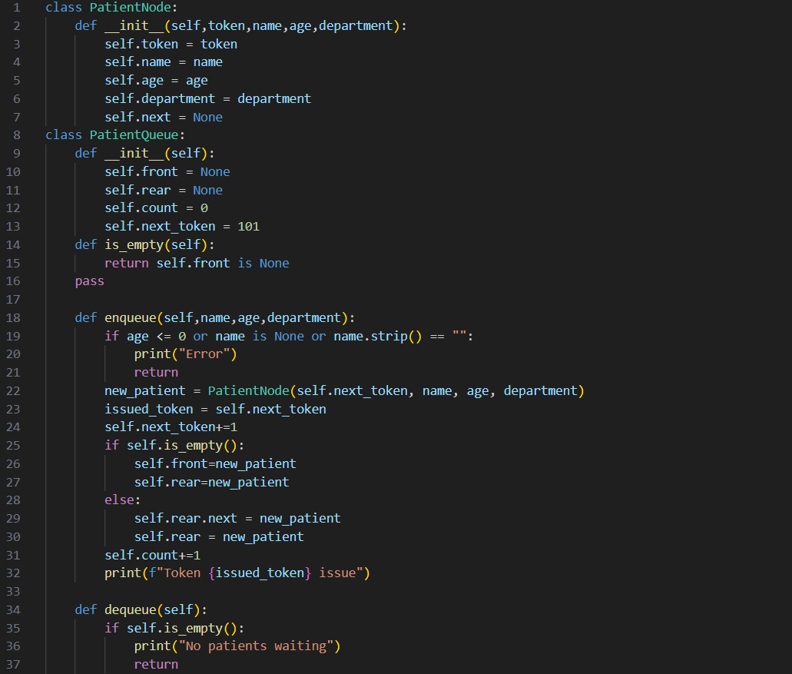
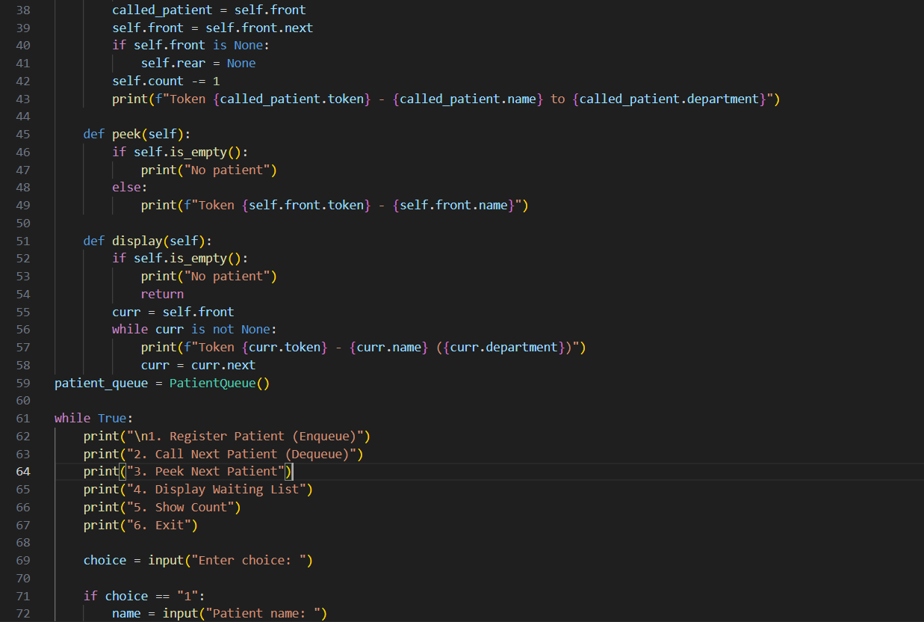
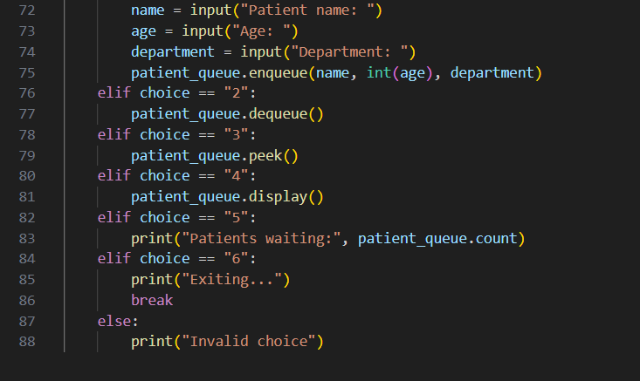
- ENQUEUE (Register Patient): Create a new node with the patient details and attach it at the REAR of the queue. The token number must be generated automatically.
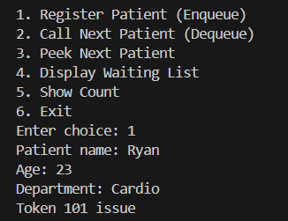
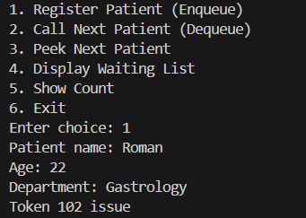
- DEQUEUE (Call Next Patient): Remove the patient at the FRONT, display "Now calling Token <no> – <name> to <department>", and free the node's memory.
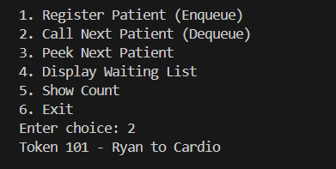

- PEEK / FRONT (Next in Line): Display the details of the patient who will be called next, without removing them.
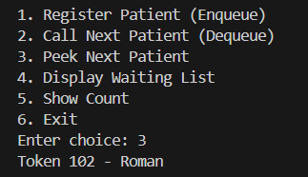
- DISPLAY (Waiting List): Traverse the queue from FRONT to REAR and print all waiting patients in order.
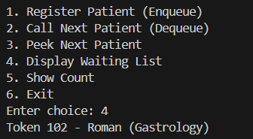
- IS_EMPTY and COUNT: Report whether the queue is empty and how many patients are currently waiting.
Before dequeue operation:
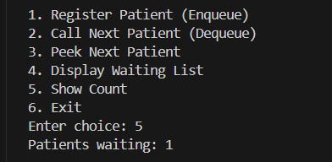

After dequeue operation:
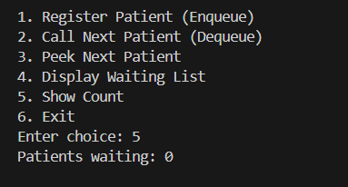
- EXIT: Free all remaining nodes before the program terminates (no memory leaks).


